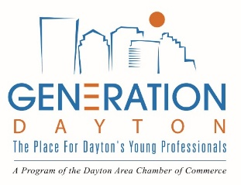
[Insert Company Logo]

Click here to enter a date.

[Employer Name]
[Street Address]
[City, State Zip]
[Email]
[Phone]

Dear [First Name] [Last Name],

Congratulations on joining the [Insert Company Name] team. [Insert Company Name] values the importance of its young professionals and has partnered with the Dayton Area Chamber of Commerce to provide networking and professional development opportunities. As part of your employment, [Insert Company Name] will sponsor your membership fee to Generation Dayton.
Generation Dayton is where the Dayton region’s young professionals come to connect with their peers and their community. This organization consists of talented young professionals seeking to meet, network, learn and establish themselves as integral components in the future success of the Dayton region and their company. Each month, Generation Dayton provides opportunities through professional development events, speaker series, community service and social networking.
To activate your membership, please contact Rachel Gensler at the Dayton Area Chamber of Commerce at rgensler@dacc.org or 937.226.8278.

Sincerely,

[Employer Name]

