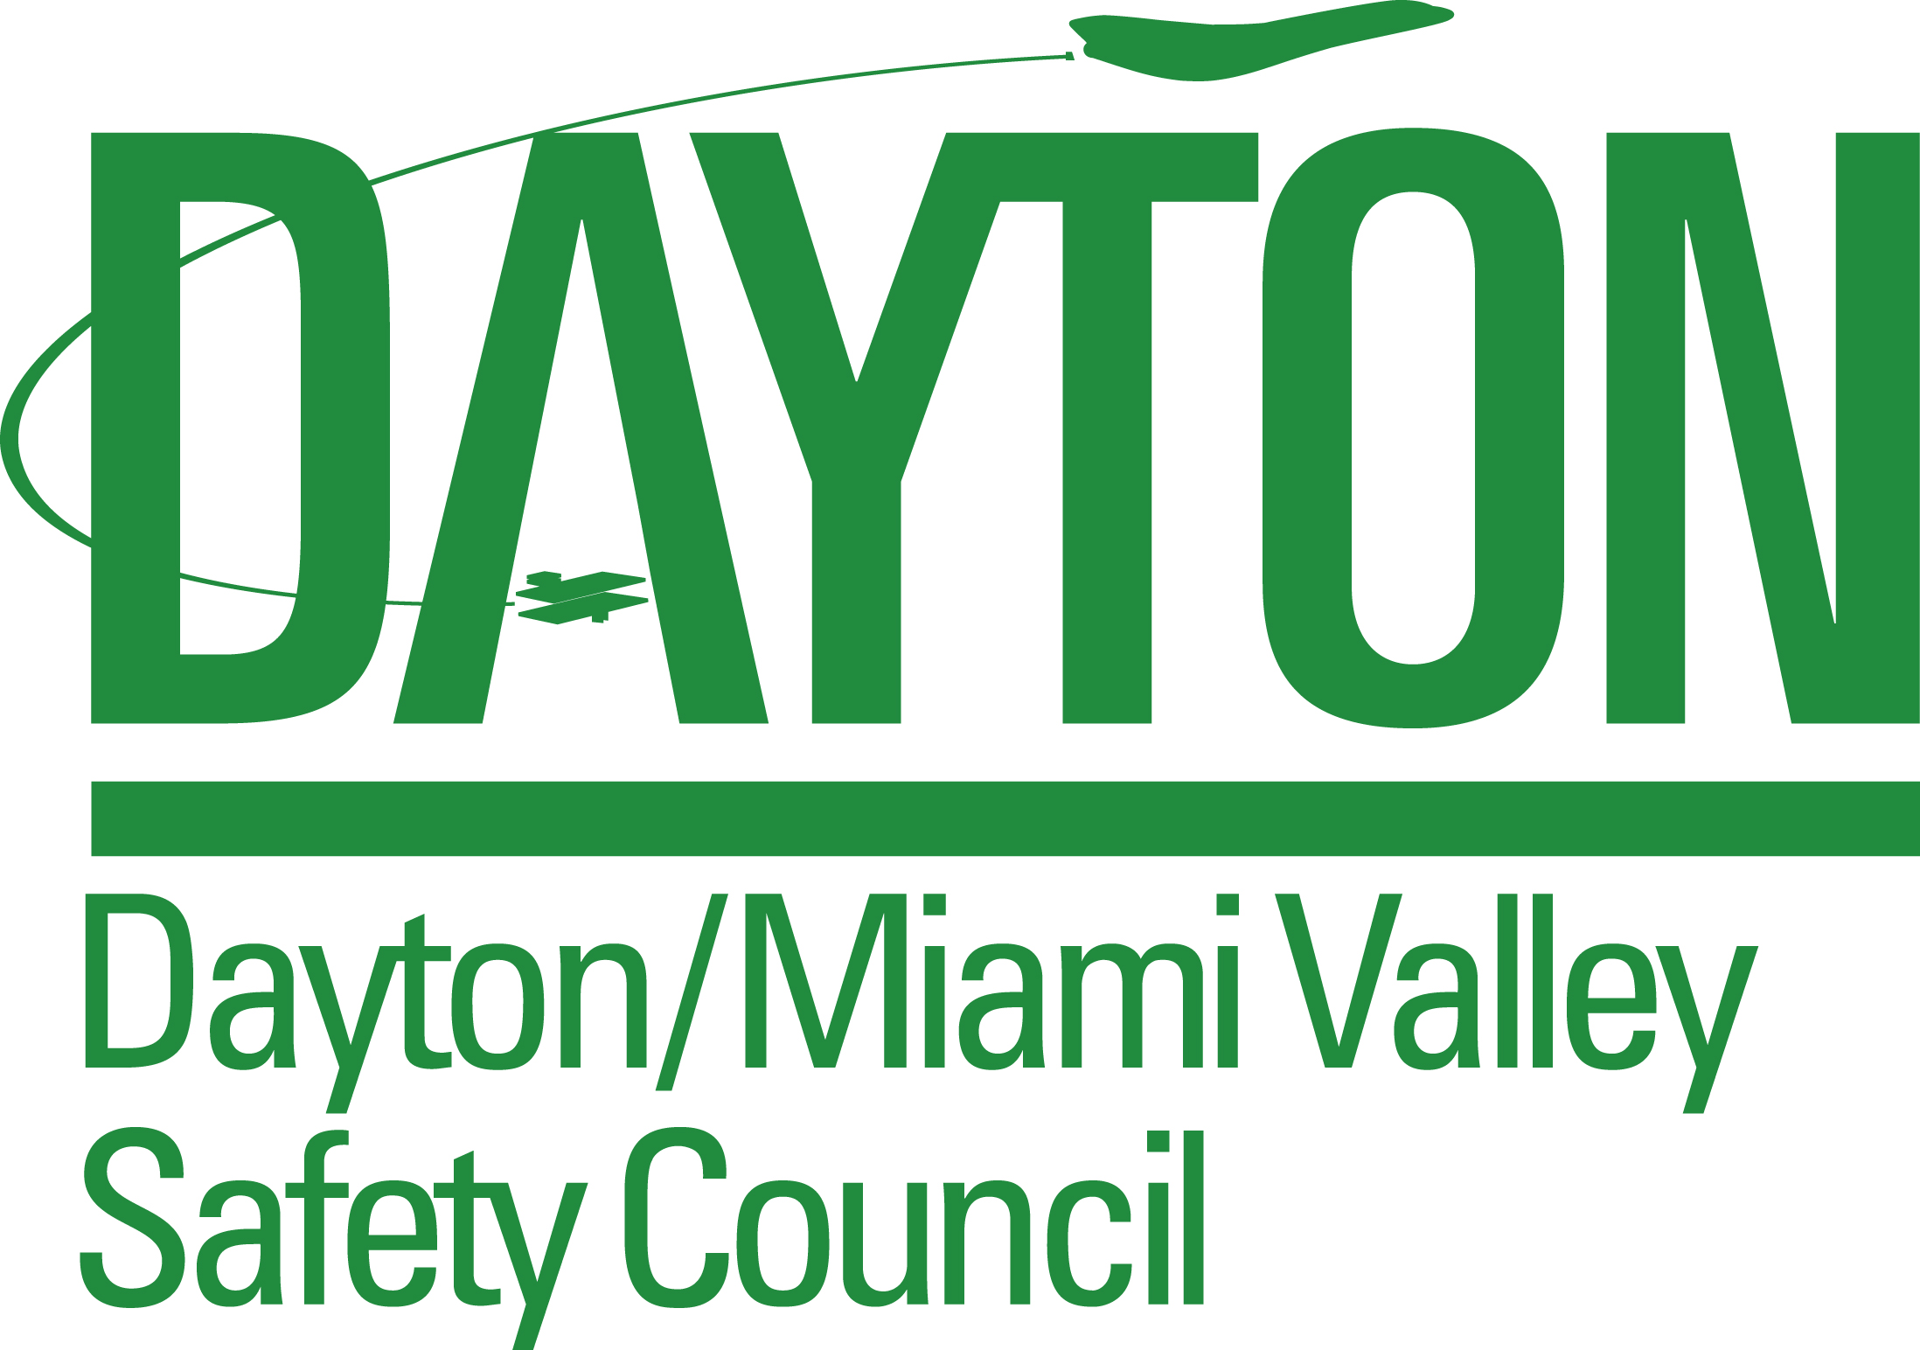

Co-sponsored by BWC’s Division of Safety and Hygiene

2018 Semi-Annual Report
1st [ ] due by July 15 2nd [ ] due by January 15
(for current period January 1 – June 30, 2018) (for current period July 1 – December 31, 2018)

Employer name Phone
Address Fax
City / State / Zip
Submitted by Date

1.) DATE OF MOST RECENT INJURY OR ILLNESS RESULTING IN DAY(S) AWAY FROM WORK

______ / ______ / ______
Month Day Year
*********************************************************************************************
Report All Information Below For CURRENT SIX MONTH PERIOD ONLY (corresponds with period identified above)
2.) Average Number of Employees

3.) Total Hours Worked (entire six month period, all employees)
*********************************************************************************************

Items 4, 5 and 6 are based on the Recordkeeping Requirements under the Occupational Safety & Health Act of 1970.
The columns listed below correspond to the columns in the OSHA 300 Log and PERRP Form 300P.

4.) Number of Deaths . . (column G in OSHA 300 Log/PERRP Form 300P)

5.) Number of occupational injuries and/or illnesses resulting in days away from work
(column H in the OSHA 300 Log/PERRP Form 300P)

6.) Number of days away from work as a result of occupational injuries and/or illnesses
(column K in the OSHA 300 Log/PERRP Form 300P)

Note: If you report a death, injury or illness resulting in days away from work in the current
six month period (item 4 or 5), the most recent date of death, injury or illness must correspond with item 1.

Please return this form to:

Olivia Morris
Dayton/Miami Valley Safety Council
22 E. Fifth Ave, Suite 200
Dayton, OH 45402-2400
omorris@dacc.org/ 937-226-8227 / Fax: 937-226-8254

