MONTGOMERY COUNTY SOLID WASTE MANAGEMENT DISTRICT

2021 Business Capital Incentive Grant

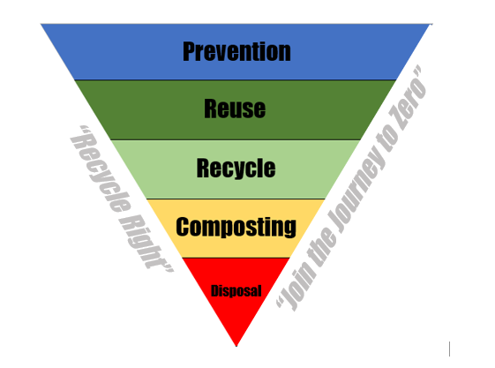

Be the CHANGE you wish to see in your COMMUNITY

GRANT GOALS

The incentive grant program for businesses will provide funding to enhance, increase and promote:
- Recycling in the County
- Waste Reduction
- Composting Opportunities

ELIGIBILITY

All businesses located within Montgomery County are eligible to participate in the program provided the organization:

- agrees to enter into a grant agreement in the form of a reimbursement/pay-back funding process to receive assistance in the business incentive grant program. Pay-Back is only if you received funds from the District and abandoned the project. Pay-back will be required in accordance with the schedule in the Agreement and attached as Exhibit A of said Agreement.

- submits annual recycling data to the District (see Recycling Survey prescribed by OEPA).

- attends application pre-submission meeting with the Grant Manager prior to the deadline for submission of the grant.

BUSINESS APPLICANTS MUST SUBMIT A LETTER OF ENDORSEMENT FROM A DISTRICT MEMBER. DISTRICT MEMBERS INCLUDE ALL 28 JURISDICITIONS WITHIN MONTGOMERY COUNTY. ENDORSEMENT LETTER MUST BE OBTAINED FROM THE JURISDICTION IN WHICH THE BUSINESS APPLICANT IS LOCATED.

FUNDING

Actual awards will vary based upon the scoring criteria, number of applications, and the funds available for the program. In 2019 the total funds available are a minimum of $130,000.00 available for capital equipment purchases.

APPLICATION

Applications must follow the format set forth on the cover sheet and must be signed by the authorized representative of the company. Where applicable, include pictures and information on equipment to be replaced or new equipment proposed.

- The Recycling Survey (included) must be submitted each year and is a prerequisite for funding.

- Eligible grant projects require a financial contribution to the project equal to thirty percent (30%) of the total project cost. Match funds for projects must be a cash contribution directly related to the project.

Example:

Funding requested $ 9,100 (Total project multiplied by .70)
Minimum Match 3,900 (30% of Total Project)
Total Project Funding $13,000

FUNDING DECISIONS

A subcommittee will review the business recycling incentive grant applications and make recommendations, based upon objective scoring criteria, to the Solid Waste Management Policy Committee. The Solid Waste Management Policy Committee will make final funding decisions. Applications for new service requests will be accepted and awarded on a first-come, first-serve basis until all funds have been expended.

ALLOWABLE USES FOR INCENTIVE FUNDS

- Capital equipment purchase to increase or expand current recycling efforts (i.e. baler/compacter).

- Specialty material recycling service (i.e. textiles/oils/containers).

- Equipment/materials/software to increase/expand operations for Processors (i.e. shredder, delivery trucks, tracking software, special equipment to increase processing of materials).

- Compost/Food Waste Management Program (purchase of on-site equipment).

UNALLOWABLE USES FOR INCENTIVE FUNDS

- Salaries or benefits of employees.*

- Land acquisition.

ACCOUNTABILITY AND REPORTING REQUIREMENTS

- Grant recipient must submit a summary report of all approved activities at the end of the project or by the end of November of the grant year, whichever date is sooner.

- Grant recipients are responsible for promoting the receipt of funds.

- Only costs incurred after the grant approval date are eligible for reimbursement. Receipt of invoice(s) and proof of payment for capital equipment purchase is required for release of grant funds by the end of October of the grant year.

- Pictures of equipment that have been funded through the grant must be provided to the District. Representatives of the District have the right to visit participating businesses at any reasonable time to evaluate the expenditure of grant funds.
- Capital equipment must be insured, and the Montgomery County Solid Waste District must be listed as an additional insured on the policy for the term of the loan/grant period.

* Costs associated with staff labor to install/build project structure may not be used as part of the total project cost calculation or to meet the 30% threshold for community investment. Labor performed by staff is not reimbursable or allowable for use in calculating total project cost.

Refer to page 5 & 6 for instructions on how to submit grant applications and the timeline for submission

Grant Submission (How To)

IMPORTANT: Prior to the submission of the grant applications, grantees will be required meet with the grant manager to ensure they have no questions about how to submit their grant application or how the grant will be administered.

All grants application and supporting documents shall be submitted via email. No paper copies will be accepted. Please scan all documents and email to John Minear (Grant Manager) at minearj@mcohio.org.

Below is a check list of documents that, at a minimum, the identified documents must be included in your grant application. Failure to submit the required information will result in point reduction and may impact the grantee’s funding.

Grant Application Submission Checklist:

Executive Summary

Detailed Project Description

Grant Detailed Budget

Financial Justification and Benefits

Copies of Quotes for Materials/Equipment

Report demonstrating anticipated waste reduction, recycling or composting tonnages that will be reduced, recycled or composted on the basis of this project being funded.

The Grant Manager will email all eligible applicants the submission documents to use outlined in the Grant Application Submission Checklist. Note: The report is to be submitted in your own format and on your company’s letterhead.

GRANT MANAGER CONTACT INFORMATION

John Minear
2550 Sandridge Drive
Moraine, Ohio 45439
937-781-3060
minearj@mcohio.org

Grant Timeline

Key Milestone | Date
Grant Opens | November 13, 2020
Grant Meeting Period | November 13, 2020 – January 2021
Grant Applications Due | March 5, 2020 at 2:00 pm via email
Grant Committee Review Period | March 5, 2021 – March 15, 2021
Prior Year Recycling Data entered in ReTrac | February 26, 2021
Grant Committee Meeting | March 25, 2021 @ 11:30 AM – 1:00 PM
District Approval Process | March 26, 2021 – April 23, 2021
Notification of Awards to Applicants | April 30, 2021
Applicants return Grant Acceptance Letter | May 7, 2021
Grantee Reimbursement Request | October 2021
Grant Final Reports Due | November 30, 2021

In the table above, if a single date is provided that is when the milestone is set for completion. If multiple dates are listed, the last date provided in the cell is the date set for completion.

SAMPLES OF SUBMISSION DOCUMENTS

