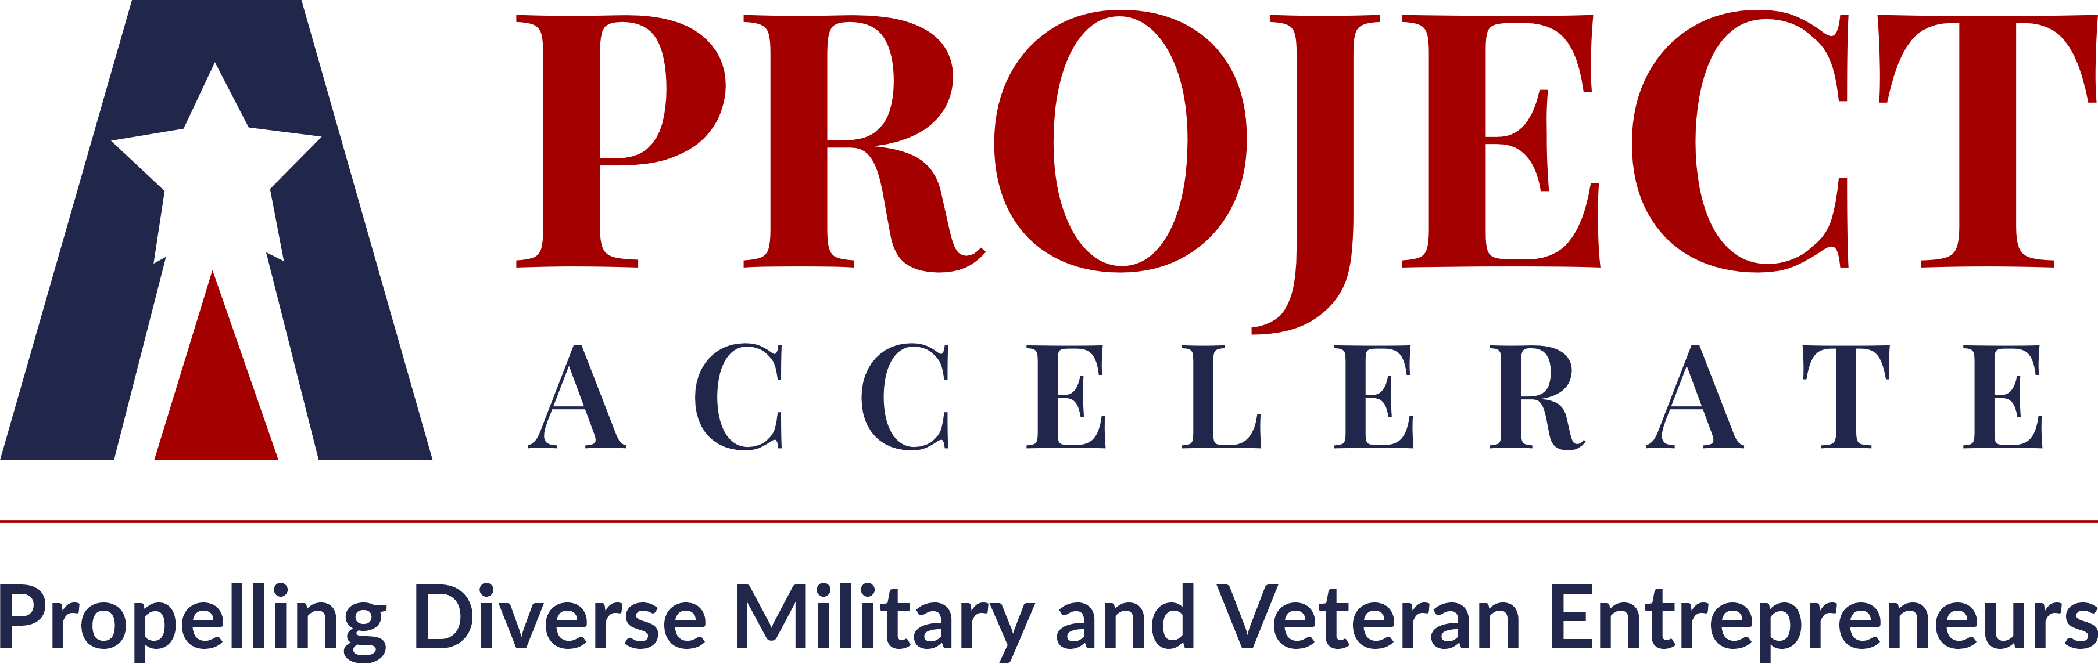

Frequently Asked Questions (FAQ’s)

What is the purpose of Project Accelerate?

Dedicated to increasing equity and inclusion within the veteran and military community, Project Accelerate, a national training program, is seeking 50 qualified cohort participants to receive training and coaching to assist with expanding their businesses within the commercial and governmental sectors and connecting with national supplier diversity partners to learn how to maximize contracting opportunities.

Who is this program for?

Project Accelerate is aimed at supporting small businesses led by veterans, military members and military spouses across diverse communities, including but not limited to those who identify as: women, Black, Hispanic and Latino, Asian and Pacific Islander, Indigenous, LGBTQ+, and people with disabilities. All companies and/or individuals that meet the program eligibility guidelines are welcome to apply.

Is this a program for Startup companies?

No, Project Accelerate is designed for companies that currently have revenue, traction and a customer base. Companies in business for at least 1 year and with revenue of $100,000 or more will be provided training to assist them with growing and scaling their business.

What topics will be covering in the training?

Project Accelerate is a national training program that will provide (3) Days of virtual training covering topics on banking and access to capital, capacity building, scaling for supplier diversity programs, revenue diversification, mergers and acquisitions, capability statements, certification programs, SBA resources, 8(a) program, FedBizOpps and general business topics.

Is this a free program?

Yes, Project Accelerate is a free training program.

Is this a Government Program?

No. The Dayton Chamber Minority Business Partnership is providing a training platform to assist diverse veteran, military and military spouses companies to grow and scale their businesses.

Is this a JPMorgan Chase Program?

No, Project Accelerate is not a program of JPMorgan Chase. Project Accelerate is a national training program provided by the Dayton Chamber of Commerce.

Who is the Dayton Area Chamber of Commerce?

The Dayton Area Chamber of Commerce Minority Business Partnership (DACC MBP) is an economic development program, which supports the growth and development of Black, Hispanic, Latino and women companies through supporting training initiatives that increase access to capital and contracts for diverse companies that will in turn increase the vibrancy and competitiveness of all businesses.

Will I be guaranteed to receive a government or commercial contract through participating in Project Accelerate?

No. We do not guarantee that participants will secure or win government or commercial contracts through participating in Project Accelerate.

What are the training dates?

Trainings will be held virtually on Zoom on Tuesday, Wednesday and Thursday from 12:00pm to 4:00pm EST.

Cohort 1: Oct. 24, Oct. 25, and Oct. 26, 2023
Cohort 2: Oct. 31, Nov. 1, and Nov. 2, 2023

How do I apply?

Once admitted, you will be grouped into cohorts and more information will be provided. If you are not admitted to the program, we will send you resources to help you on your entrepreneurial journey. We don’t want any company left behind. Applications open September 5th and close September 30, 2023.
You can apply HERE.
What is the selection process and criteria?

Project Accelerate is seeking highly motivated and growth oriented military and veteran entrepreneurial leaders that operate companies with revenue, traction and a customer base. Companies in business for at least 1 year and with revenue of $100,000 or more will be considered for the program. Companies from all sectors are encouraged to apply and the CEO or President should attend as the program focuses on developing growth strategies for the organization

We will evaluate all applications. A committee will review applications and select up to 50 participants based on variables (such as growth plan, market opportunity, financial sustainability, and team).

Additional Questions

For questions not answered on the above FAQs? Please send inquiries to ProjectAccelerate@dacc.org.

